Agronomy Research XX(x), xx–xx, 2020

Title of the paper should be informative but concise

I. Surnameone¹, I. Surnametwo^{1,2}, I.N. Surnamethree³ and I. Surnamefour^{1,*}

¹University of Someplace, Faculty of Something, Department of Somethingelse, Street address xx, postal code Town, Country
²University of Someotherplace, Faculty of Something, Department of Somethingelse, Street address xx, postal code Town, Country
³University of Somethirdplace, Faculty of Something, Department of Somethingelse, Street address xx, postal code Town, Country
*Correspondence: me.myself@email.xyz

Abstract. The abstract of the full paper should be in length at least 150 but not exceed 250 words. It should be in one paragraph. The abstract should be a stand-alone statement that briefly conveys the essential information of a paper; presents the objective, methods, results, and conclusions of a research project; has a brief, non-repetitive style. The abstract should not include citations, background information, detailed description of methods, or equations.

Key words: first keyword, second keyword, third keyword, etc. in alphabetical order

INTRODUCTION

Manuscript must be in English (British spelling). English is revised by a language reviewer, but authors are strongly urged to have the papers reviewed linguistically prior to submitting.
Page size should be ISO B5 (17.6 x 25.0) with 2 cm margins on all sides. Use single line spacing and justify the text. Use font Times New Roman, size 11 in the text. For Abstract, Key words, References and tables use Times New Roman, size 10. Use first line indentation 0.8.
Don not use page numbering!
An introduction should state the SUBJECT of the research. It might include (depending on the readers' knowledge) a small amount of BACKGROUND information about the history or theory of the subject, definitions of key terms the readers might not know, explanations of the technical principles, basic laws, formulas, equations, and the like.
An introduction should also define the PROBLEM to be addressed and explain the SCOPE of the document.
When using citations in the introduction or anywhere else in the paper format should be as follows: when there is only one author (Surname, 2020), when there are two authors (Surnameone & Surnametwo, 2020), when there are more than two authors (Surname et al, 2020).
When using citations with a name in the text, use it in a similar fashion e.g. ‘Surname (2020) has shown that…’, ‘Surnameone & Surnametwo (2020) have shown that…’, or ‘Surname et al (2020) have shown that…’
When referring to more than one publication, arrange them using the following keys: 1. year of publication (ascending), 2. alphabetical order for the same year of publication: (Behera & Varma, 2019; Doddapaneni et al., 2018; Haiba, 2017).
Use single (‘……’) instead of double quotation marks (“……”).
Use italics for Latin biological names and for statistical terms (t-test, n = 193, P > 0.05)

MATERIALS AND METHODS

Materials and Methods sections should include full description of all the materials, chemicals, instrumentation, and methodologies that were used in the work.
All tables must be referred to in the text (Table 1; Tables 1, 2).
All figures must be referred to in the text (Fig. 1; Fig. 1, a, b; Figs 1, 3; Figs 1–3).

Use subdivisions when necessary
Using subdivisions often helps to organize the content of your paper better. In Materials and Methods chapter, the possible subdivisions could include: chemicals, solutions, materials, instrumentation, methods, software etc.

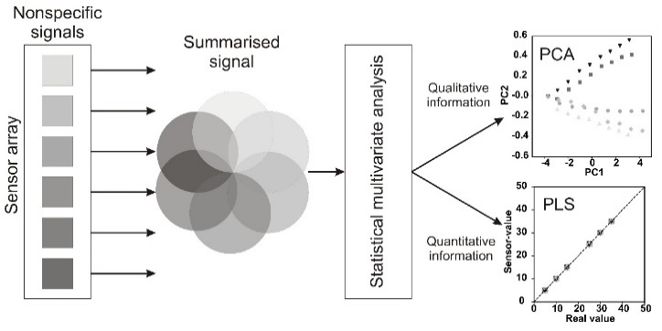

Figure 1. Use schematics and figures that are clearly titled and labelled. Title of the figure is situated below the figure. Use font Arial, size 10 within the figures. Use only black and white for figures.

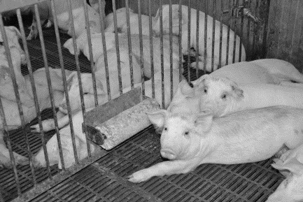 | 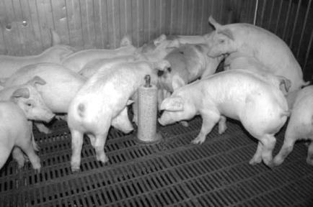 | 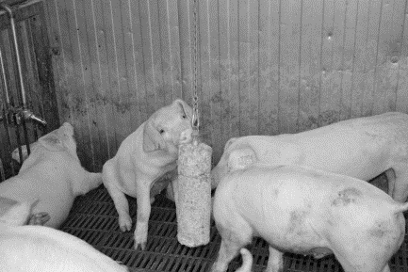
Figure 2. When using photographs as figures, make sure that they are viewable in black and white as well.
Table 1. Tables should be clearly titled. Title of the table is situated above the table. Do not use vertical lines as dividers, only horizontal lines are allowed. Primary column and row headings should start with an initial capital, secondary headings without initial capital. Tables should fit within the margins of the page!
Type of green area | Area  (km²) | Greening  waste  (t year⁻¹) | Bioethanol  potential  (t year⁻¹) | Coverage  of fuel  (%)
Public greenery | 3.72² | 4,285 | 268 | 21.8
Private yards | 7.09² | 8,170 | 511 | 41.5
Parks | 0.42² | 484 | 30.3 | 2.46
Graveyards | 0.41² | 472 | 29.5 | 2.40
Avenues | 1.00² | 1,152 | 72.1 | 5.85
TOTAL | 12.64 | 1,456 | 911 | 74
Regularly maintained parks and public greenery¹ | 3.15 | 3,628.7 | 227 | 18.4
¹ Data according to official city records (Tartu municipal administration, 2010)
² Data based on map analysis

Theory and modelling
If your methodology chapter includes theoretical section or a mathematical model, you should use Microsoft Office’s Equation Editor to formulate equations e.g.

$$A=\frac{1}{n}\sum_{i=1}^{n}{a_{i}}$$ | (1)

where: n – data-set extent; a_{i} – variable at the i index of a data-set, N.

All equations should be clearly described with all variables and constants defined.

RESULTS AND DISCUSSION

In the “Results and discussion” section all pertinent results should be presented in a logical order and discussed. Discussion portion could also include significance of the results in context of the research field, and suggestions for the future research.

Figure 3. All figures in the results section should be clearly titled and labelled. Within the figure use font Arial, size 10. Make sure the figure is understandable in black and white. Don’t use frames around the figure.

When presenting the numerical values of your results, use period ‘.’ (not ‘,’) to separate decimals: 0.6 ± 0.2; use a ‘comma’ for thousands - 1,230.4 (one thousand two hundred and thirty and four tenths); use degrees and percentages without space: 5°, 5% (not 5 °, 5 %); when using degree with scale then use space between the number and degree 5 °C (not 5°C); use ‘–’ (not ‘-’) and without space: pp. 27–36, 1998–2000, 4–6 min, 3–5 kg; in case of other units use spaces: 5 h, 5 kg, 5 m, C : D = 0.6 ± 0.2; for complex units use ‘kg ha⁻¹’ (not ‘kg/ha’); for degree use the symbol ‘ ° ’ not superscript o: 5 °C (not 5 ºC). For all other cases use SI system requirements.

CONCLUSIONS

The Conclusions should not just restate the main results but draw wider conclusions from the results. It may include bulleted items. Conclusions can also include assessment and suggestions.

ACKNOWLEDGEMENTS. The acknowledgements should include all people, institutions and funds that have helped to achieve the goals of the research but have not been mentioned as authors. Logo of the funding organization can be included if necessary.

REFERENCES

Full list of authors is required for all references. If the source title is not in English, it should be translated to English and at the end of reference, the original language noted.

Commission Regulation (EC) No 2073/2005 of 15 November 2005 on microbiological criteria for foodstuffs. 2005. Official Journal of the European Union L338, 1–26.
Biofuels 2019. https://ec.europa.eu/energy/en/topics/renewable-energy/biofuels/overview. Accessed 13.12.2019.
Microbiology of food and animal feeding stuffs - Horizontal method for enumeration of Clostridium perfringens: ISO 7937:2004 (2004) Available at: https://www.lvs.lv/lv/products/16653, 1 March 2017.
Noréus, O. & Trigell, A. 2018, Measurement of terrain values and drawbar pull for six wheeled vehicle on sand. In: 16th International Conference of the International Society for Terrain Vehicle Systems. ISTVS, Turin, pp. 250–257 (in Italian).
Raud, M., Kesperi, R., Oja, T., Olt, J., & Kikas, T. 2014. Utilization of urban waste in bioethanol production: Potential and technical solutions. Agronomy Research 12, 397-406.
Shaldaeva, T.M., Vysochina, G.I. & Kostikova, V.A. 2018. Phenolic compounds and the antioxidant activity of certain species of the genus Filipendula Mill. (Rosaceae). Vestnik VSU, Series: Chemistry. Biology. Pharmacy 1, 204–212 (in Russian).
DIN EN 12114. 2000. ‘Thermal performance of buildings – Air permeability of building components and building elements - Laboratory test method’. European standards, Pilsen, Czech Republic

For more information on the full paper format and requirements, please also see http://agronomy.emu.ee/GeneralGuidelineForAuthors.pdf.

