Agronomy Research 20(x), xx–xx, 2022

Title of the paper should be informative but concise

I. Surnameone¹, I. Surnametwo^{1,2}, I.N. Surnamethree³ and I. Surnamefour^{1,*}

¹University of Someplace, Faculty of Something, Department of Somethingelse,
Street address xx, postal code Town, Country
²University of Someotherplace, Faculty of Something, Department of Somethingelse, Street address xx, postal code Town, Country
³University of Somethirdplace, Faculty of Something, Department of Somethingelse, Street address xx, postal code Town, Country
*Correspondence: me.myself@email.xyz

Received: date; Accepted: date; Published: date.

Abstract. The abstract of the full paper should not exceed 250 words. It should be in one paragraph. The abstract should be a stand-alone statement that briefly conveys the essential information of a paper; presents the objective, methods, results, and conclusions of a research project; has a brief, non-repetitive style. The abstract should not include citations, background information, detailed description of methods, or equations.

Key words: first keyword, second keyword, third keyword, etc. in alphabetical order.

INTRODUCTION

Manuscript must be in English (British spelling). English is revised by a language reviewer, but authors are strongly urged to have the papers reviewed linguistically prior to submitting.
Page size should be ISO B5 (17.6 × 25.0) with 2cm margins on all sides. Use single line spacing and justify the text. Use font Times New Roman, size 11 in the text. For Abstract, Key words, References and tables use Times New Roman, size 10. Use first line indentation 0.8.
Don not use page numbering!
An introduction should state the SUBJECT of the research. It might include (depending on the readers' knowledge) a small amount of BACKGROUND information about the history or theory of the subject, definitions of key terms the readers might not know, explanations of the technical principles, basic laws, formulas, equations, and the like.
An introduction should also define the PROBLEM to be addressed and explain the SCOPE of the document.
When using citations in the introduction or anywhere else in the paper format should be as follows: when there is only one author (Surname, 2020), when there are two authors (Surnameone & Surnametwo, 2020), when there are more than two authors (Surname et al., 2020).
When using citations with a name in the text, use it in a similar fashion e.g. ‘Surname (2020) has shown that…’, ‘Surnameone & Surnametwo (2020) have shown that…’, or ‘Surname et al. (2020) have shown that…’
When referring to more than one publication, arrange them using the following keys: 1. year of publication (ascending), 2. alphabetical order for the same year of publication: (Haiba, 2017; Doddapaneni et al., 2018; Behera & Varma, 2019).
Use single (‘……’) instead of double quotation marks (“……”).
Use italics for Latin biological names and for statistical terms (t-test, n = 193, P > 0.05).

MATERIALS AND METHODS

Materials and Methods sections should include full description of all the materials, chemicals, instrumentation, and methodologies that were used in the work.
All tables must be referred to in the text (Table 1; Tables 1, 2).

Table 1. Tables should be clearly titled. Title of the table is situated above the table. Do not use vertical lines as dividers, only horizontal lines are allowed. Primary column and row headings should start with an initial capital, secondary headings without initial capital. Tables should fit within the margins of the page (13.6 cm × 21.0 cm)!
Type of green area | Area  (km²) | Greening  waste  (t year⁻¹) | Bioethanol  potential  (t year⁻¹) | Coverage  of fuel  (%)
Public greenery | 3.72² | 4,285 | 268 | 21.8
Private yards | 7.09² | 8,170 | 511 | 41.5
Parks | 0.42² | 484 | 30.3 | 2.46
Graveyards | 0.41² | 472 | 29.5 | 2.40
Avenues | 1.00² | 1,152 | 72.1 | 5.85
TOTAL | 12.64 | 1,456 | 911 | 74
Regularly maintained parks and public greenery¹ | 3.15 | 3,628.7 | 227 | 18.4
¹ Data according to official city records (Tartu municipal administration, 2010); ² Data based on map analysis.

Use subdivisions when necessary
Using subdivisions often helps to organize the content of your paper better. In Materials and Methods chapter, the possible subdivisions could include: chemicals, solutions, materials, instrumentation, methods, software etc.
All figures must be referred to in the text (Fig. 1; Fig. 1, a, b; Figs 1, 3; Figs 1–3).

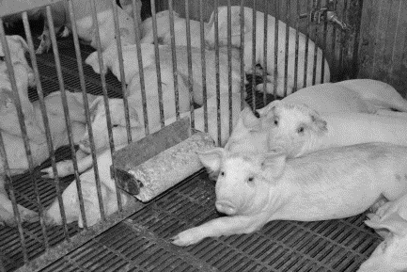 | 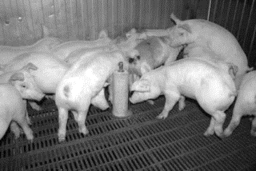 | 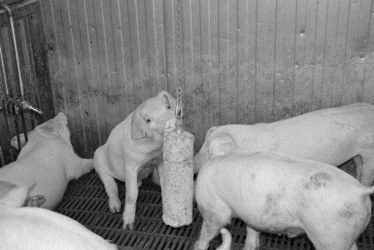

Figure 1. When using photographs as figures, make sure that they are viewable in black and white as well.
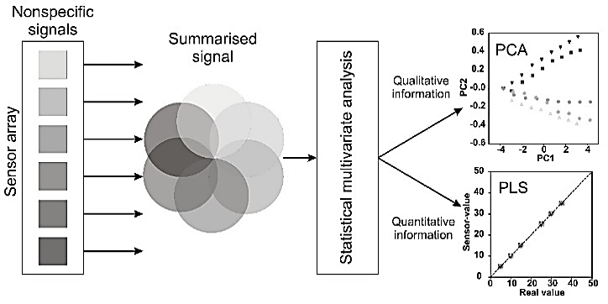

Figure 2. Use schematics and figures that are clearly titled and labelled. Title of the figure is situated below the figure. Use font Arial, size 10 within the figures.

Figure 3. All figures in the results section should be clearly titled and labelled. Within the figure use font Arial, size 10. Don’t use frames around the figure.

Theory and modelling
If your methodology chapter includes theoretical section or a mathematical model, you should use Microsoft Office’s Equation Editor to formulate equations e.g.
$$A=\frac{1}{n}\sum_{i=1}^{n}{a_{i}}$$ | (1)
where n – data-set extent; a_{i} – variable at the i index of a data-set, N.

All equations should be clearly described with all variables and constants defined.

RESULTS AND DISCUSSION

In the ‘Results and discussion’ section all pertinent results should be presented in a logical order and discussed. Discussion portion could also include significance of the results in context of the research field, and suggestions for the future research.

When presenting the numerical values of your results, use period ‘.’ (not ‘,’) to separate decimals: 0.6 ± 0.2; use a ‘comma’ for thousands - 1,230.4 (one thousand two hundred and thirty and four tenths); use degrees and percentages without space: 5°, 5% (not 5 °, 5 %); when using degree with scale then use space between the number and degree 5 °C (not 5°C); use ‘–’ (not ‘-’) and without space: pp. 27–36, 1998–2000,
4–6 min, 3–5 kg; in case of other units use spaces: 5 h, 5 kg, 5 m, 10 mL, C : D = 0.6 ± 0.2; for complex units use ‘kg ha⁻¹’ (not ‘kg/ha’); for degree use the symbol ‘ ° ’ not superscript o: 5 °C (not 5 ºC). For all other cases use SI system requirements.

CONCLUSIONS

The Conclusions should not just restate the main results but draw wider conclusions from the results. It may include bulleted items. Conclusions can also include assessment and suggestions.

ACKNOWLEDGEMENTS. The acknowledgements should include all people, institutions and funds that have helped to achieve the goals of the research but have not been mentioned as authors. Logo of the funding organization can be included if necessary.

DECLARATION OF AI USE. The author(s) declare that artificial intelligence (AI) tools were used in the preparation of this manuscript. AI-assisted technologies were utilized for [language editing / grammar refinement / structural organization / preliminary drafting support]. All AI-generated content was carefully reviewed, revised, and validated by the author(s). The author(s) take full responsibility for the accuracy, integrity, and originality of the final manuscript. No AI tools were used to generate data, fabricate references, or replace scholarly analysis.

REFERENCES

Full list of authors is required for all references. If the source title is not in English, it should be translated to English and at the end of reference, the original language noted.

Biofuels 2019. https://ec.europa.eu/energy/en/topics/renewable-energy/biofuels/overview. Accessed 13.12.2019.
Bulgakov, V., Adamchuk, V., Arak, M. & Olt, J. 2018. The theory of cleaning the crowns of standing beet roots with the use of elastic blades. Agronomy Research 16(5), 1931–1949. doi: 10.15159/AR.18.213
Central Statistical Bureau of Latvia. 2018. Forestry in 2017. Available at https://www.zm.gov.lv/public/ck/files/skaitlifakti_EN_2018web.pdf (in Latvian).
Commission Regulation (EC) No 2073/2005 of 15 November 2005 on microbiological criteria for foodstuffs. 2005. Official Journal of the European Union L338, 1–26.
DIN EN 12114. 2000. ‘Thermal performance of buildings – Air permeability of building components and building elements - Laboratory test method’. European standards, Pilsen, Czech Republic
EVS-EN ISO 14126. 2000. ‘Fibre reinforced plastic composites - Determination of compressive properties in the in-plane direction’. Estonia centre for standardization, Tallinn, Estonia & International Organization for Standardization, Geneva, Switzerland.
FAO (Food and Agriculture Organization of the United Nation). 2006. FAO Plant Nutrition for Food Security: FAO Fertilizer and Plant Nutrition Bul. 16. Rome, pp. 366.
Haiba, E. 2017. Optimization of Sewage Sludge Composting: Problems and Solutions. PhD Thesis, Tallinn University of Technology, Tartu, Estonia, 162 pp.
Latvian State Forests 2015. Planting, sowing and replenishment instructions. Available at https://www.mezsaimnieks.lv/images/userfiles/stadi_final_WEB3.pdf (in Latvian)
Noréus, O. & Trigell, A. 2008. Measurement of terrain values and drawbar pull for six wheeled vehicle on sand. In: 16th International Conference of the International Society for Terrain Vehicle Systems. ISTVS, Turin, pp. 250–257 (in Italian).
Raskoshnaya, T.A., Semenikhina, V.F., Rozhkova, I.V. & Begunova, A.V. 2016. Development of culture medium and modes of cultivation of Lactobacillus reuteri for synthesis of bacterial concentrate. Equipment and Technology of Food Production Facilities 42(3),
56–62 (in Russian).
Raud, M., Kesperi, R., Oja, T., Olt, J. & Kikas, T. 2014. Utilization of urban waste in bioethanol production: Potential and technical solutions. Agronomy Research 12, 397–406.
SAS (Statistical Analysis System). 2004. SAS/STAT user’s guide. Proprietary software version 9.00. SAS Inst., Inc., Cary, NC.
Shaldaeva, T.M., Vysochina, G.I. & Kostikova, V.A. 2018. Phenolic compounds and the antioxidant activity of certain species of the genus Filipendula Mill. (Rosaceae). Vestnik VSU, Series: Chemistry. Biology. Pharmacy 1, 204–212 (in Russian).
Schiavone, A., De Marco, M. & Gasco, L. 2014. Nutrient digestibility of Hermetia illucens and Tenebrio molitor meal in broiler chickens. In: Proc. Conference Insects to Feed The World, Abstract Book. Netherlands, pp. 84.
Stępień, A., Wojtkowiak, K. & Pietrzak-Fiećko, R. 2018. Influence of a crop rotation system
and agrotechnology level on the yielding and seed quality of winter rapeseed
(Brassica napus L.) varieties Castille and Nelson. J. Elem. 23(4), 1281–1293.
doi: 10.5601/jelem.2017.22.4.1558

For more information on the full paper format and requirements, please also see http://agronomy.emu.ee/GeneralGuidelineForAuthors.pdf.

