Supplemental material

Title: Germplasm diversity of sunflower volatile terpenoid profiles across vegetative and reproductive organs

Authors: Keivan Bahmani, Madlyn Giguere, Jordan A. Dowell, Chase M. Mason

Number of tables: 14; Number of figures: 3

Table S1. The 12 cultivated sunflower genotypes (inbred lines) for which volatile phytochemistry was assessed in this study. All inbred lines were obtained from the USDA National Plant Germplasm System. The North Central Regional Plant Introduction Station (NCRPIS, Ames, IA) accession number is listed, along with the USDA Plant Introduction number for the USDA germplasm accession or French INRA (Institut National de la Recherche Agronomique) accession from which the inbred line was derived through single-seed descent. These ’Core 12’ lines represent approximately half of the allelic diversity present in the Sunflower Association Mapping (SAM) panel of 288 accessions (Mandel et al., 2011). Breeding pool refers to membership in either the maintainer (HA) or restorer (RHA) breeding pools, or open-pollinated varieties (OPV). Market class refers to Oil and NonOil varieties within the HA and RHA breeding pools, a distinction that does not apply clearly to OPV varieties nor line 262 from INRA
Line  (full name) | Line  (short name) | Breeding pool/ market class | USDA NCRPIS  accession | Derived from USDA or INRA accession | Original source
UGA-SAM1-020 | SAM 020 | HA-Oil | Ames 31713 | PI 597368 | USDA-developed
UGA-SAM1-022 | SAM 022 | RHA-Oil | Ames 31715 | PI 597373 | USDA-developed
UGA-SAM1-027 | SAM 027 | HA-NonOil | Ames 31720 | PI 599783 | USDA-developed
UGA-SAM1-093 | SAM 093 | OPV | Ames 31785 | PI 386230 | Khazakhstan
UGA-SAM1-094 | SAM 094 | OPV | Ames 31786 | PI 476853 | Burpee (Mammoth)
UGA-SAM1-176 | SAM 176 | HA-Oil | Ames 31868 | PI 599778 | USDA-developed
UGA-SAM1-185 | SAM 185 | HA-Oil | Ames 31877 | PI 599984 | USDA-developed
UGA-SAM1-191 | SAM 191 | RHA-Oil | Ames 31883 | PI 603989 | USDA-developed
UGA-SAM1-203 | SAM 203 | RHA-Oil | Ames 31895 | PI 617099 | USDA-developed
UGA-SAM1-237 | SAM 237 | RHA-NonOil | Ames 31929 | PI 664202 | USDA-developed
UGA-SAM1-240 | SAM 240 | HA-NonOil | Ames 31932 | PI 664225 | USDA-developed
UGA-SAM1-262 | SAM 262 | HA-INRA | Ames 31954 | SF 230 | INRA (France)

Table S2. Total number of volatile compounds detected and identified via SPME-GC-MS in each genotype (pooling all four organ types assessed), as well as the proportional breakdown of compounds classified as terpenoids (divided into monoterpenoids, sesquiterpenoids, and diterpenoids), fatty acid derivatives, and other compounds. Percentages may not sum to exactly 100% due to rounding
Core 12 genotype | Number of compounds | % terpenoids | % monoterpenoids | % sesquiterpenoids | % diterpenoids | % fatty acid derivatives | % other compounds
SAM 020 | 82 | 82.9 | 34.1 | 47.6 | 1.2 | 0 | 17.0
SAM 022 | 90 | 80.0 | 38.8 | 40.0 | 1.1 | 1.1 | 18.9
SAM 027 | 107 | 74.8 | 37.5 | 36.4 | 0.9 | 3.7 | 21.5
SAM 093 | 102 | 78.4 | 46.0 | 30.4 | 2.0 | 0 | 21.6
SAM 094 | 95 | 80.0 | 44.2 | 34.8 | 1.0 | 0 | 20.0
SAM 176 | 72 | 80.5 | 37.5 | 40.3 | 2.7 | 0 | 19.4
SAM 185 | 84 | 85.7 | 40.5 | 44.0 | 1.2 | 0 | 14.2
SAM 191 | 85 | 88.2 | 41.1 | 45.8 | 1.2 | 0 | 11.7
SAM 203 | 82 | 79.3 | 37.8 | 40.2 | 1.2 | 0 | 20.7
SAM 237 | 82 | 81.7 | 37.8 | 42.7 | 1.2 | 1.2 | 17.1
SAM 240 | 93 | 83.8 | 39.8 | 43.0 | 1.0 | 0 | 16.2
SAM 262 | 71 | 77.5 | 42.2 | 33.9 | 1.4 | 1.4 | 21.1

Table S3. Volatile profiles as assessed by SPME-GC-MS in the four organ types assessed (averaged across the twelve plant genotypes). The average number of compounds detected and total volatile abundance (mass-normalized peak area) are reported, along with the proportional breakdown of mass-normalized peak area by compound class: terpenoids (divided into monoterpenoids, sesquiterpenoids, and diterpenoids), and other compounds. Values represent mean ± SE for each metric reported, calculated across all replicate samples. Percentages may not sum to exactly 100% due to rounding
Organ | Number of compounds | Total volatile abundance | % terpenoids | % mono-terpenoids | % sesqui-terpenoids | % diterpenoids | % fatty acid derivatives | % other compounds
Petals | 16.8 ± 0.6 | 33064 ± 2517 | 98.1 ± 0.3 | 94.5 ± 0.6 | 3.6 ± 0.5 | 0 | 0.03 ± 0.02 | 1.9 ± 0.3
Disc florets | 24.3 ± 0.8 | 50409 ± 3589 | 96.8 ± 0.5 | 90.3 ± 1.0 | 6.5 ± 0.8 | 0.01 ± 0.00 | 0.01 ± 0.01 | 3.2 ± 0.5
Bracts | 23.4 ± 1.3 | 28401 ± 3177 | 96.1 ± 0.6 | 80.5 ± 1.9 | 15.5 ± 1.6 | 0.06 ± 0.03 | 0 | 3.9 ± 0.6
Leaves | 29.2 ± 1.7 | 23495 ± 2983 | 93.2 ± 0.9 | 54.5 ± 2.7 | 38.2 ± 2.8 | 0.50 ± 0.07 | 0.02 ± 0.02 | 6.8 ± 0.9

Table S4. Volatile profiles as assessed by SPME-GC-MS in the twelve plant genotypes assessed (averaged across the four organ types). The average number of compounds detected and total volatile abundance (mass-normalized peak area) are reported, along with the proportional breakdown of mass-normalized peak area by compound class: terpenoids (divided into monoterpenoids, sesquiterpenoids, and diterpenoids), and other compounds. Values represent mean ± SE for each metric reported, calculated across all replicate samples. Percentages may not sum to exactly 100% due to rounding
Core 12 genotype | Number of compounds | Total volatile abundance | % terpenoids | % monoterpenoids | % sesquiterpenoids | %  diterpenoids | % fatty acid derivatives | % other compounds
SAM 020 | 24.1 ± 1.6 | 30864 ± 4165 | 94.8 ± 1.9 | 69.4 ± 5.0 | 25.2 ± 4.2 | 0.20 ± 0.08 | 0 | 5.2 ± 1.9
SAM 022 | 22.8 ± 1.3 | 33341 ± 6724 | 94.8 ± 1.3 | 74.0 ± 4.1 | 20.5 ± 3.7 | 0.24 ± 0.10 | 0.03 ± 0.03 | 5.1 ± 1.3
SAM 027 | 23.0 ± 1.3 | 32098 ± 2819 | 95.8 ± 2.4 | 80.7 ± 2.4 | 15.1 ± 2.3 | 0.07 ± 0.03 | 0.04 ± 0.04 | 4.0 ± 0.6
SAM 093 | 20.2 ± 1.3 | 23108 ± 3258 | 94.3 ± 1.5 | 81.0 ± 3.4 | 13.1 ± 2.5 | 0.18 ± 0.10 | 0 | 5.6 ± 1.5
SAM 094 | 25.1 ± 1.7 | 35821 ± 4445 | 96.2 ± 1.0 | 79.6 ± 3.6 | 16.5 ± 3.4 | 0.01 ± 0.01 | 0 | 3.8 ± 1.0
SAM 176 | 20.2 ± 1.2 | 28694 ± 3731 | 96.7 ± 0.7 | 82.4 ± 3.3 | 14.0 ± 2.7 | 0.21 ± 0.09 | 0 | 3.2 ± 0.7
SAM 185 | 24.0 ± 1.7 | 25324 ± 2146 | 95.6 ± 1.4 | 76.8 ± 4.2 | 18.6 ± 3.9 | 0.11 ± 0.06 | 0 | 4.3 ± 1.4
SAM 191 | 25.9 ± 1.7 | 31366 ± 3422 | 95.7 ± 0.8 | 68.1 ± 5.9 | 27.3 ± 5.3 | 0.19 ± 0.09 | 0 | 4.2 ± 0.8
SAM 203 | 20.6 ± 1.1 | 35429 ± 4894 | 95.9 ± 0.8 | 86.4 ± 3.0 | 9.2 ± 2.3 | 0.28 ± 0.10 | 0 | 4.0 ± 0.8
SAM 237 | 25.6 ± 2.6 | 25926 ± 2156 | 96.0 ± 0.7 | 74.7 ± 5.6 | 21.1 ± 5.3 | 0.09 ± 0.05 | 0.04 ± 0.04 | 3.9 ± 0.7
SAM 240 | 30.4 ± 2.1 | 52673 ± 4491 | 97.9 ± 0.2 | 79.1 ± 4.1 | 18.8 ± 3.9 | 0.02 ± 0.02 | 0 | 2.0 ± 1.1
SAM 262 | 24.2 ± 2.5 | 34318 ± 6058 | 94.6 ± 1.8 | 82.3 ± 4.2 | 12.1 ± 2.9 | 0.19 ± 0.08 | 0.08 ± 0.08 | 5.2 ± 1.9

Table S5. Fold-change variation in volatile compound profile metrics across the Core 12 genotypes and four organ types (48 genotype-by-organ combination means)
Number of compounds | Total volatile abundance | % terpenoids | % monoterpenoids | % sesquiterpenoids | % diterpenoids | % fatty acid derivatives | % other compounds
3.21 | 9.34 | 1.14 | 2.57 | 110.8 | 26.7 | 20 | 21.5

Table S6. Fold-change variation in volatile compound profile metrics across the Core 12 genotypes within the four organ types. A cell with (-) indicates that n≤1 genotype within the organ type contained a non-zero value for the metric
Organ | Number of compounds | Total volatile abundance | % terpenoids | % monoterpenoids | % sesquiterpenoids | % diterpenoids | % fatty acid derivatives | % other compounds
Petal | 1.62 | 2.28 | 1.03 | 1.08 | 11.60 | - | 1.00 | 6.00
Disk Floret | 1.49 | 2.35 | 1.05 | 1.10 | 4.34 | 1.33 | 10.00 | 5.15
Bract | 2.19 | 3.74 | 1.07 | 1.27 | 4.28 | 4.28 | - | 5.78
Leaf | 2.08 | 5.98 | 1.11 | 1.80 | 2.52 | 16.00 | 0.20 | 4.77

Table S7. Fold-change variation in volatile compound profile metrics across the four organs within each Core 12 genotype. A cell with (-) indicates that n≤1 tissue type within the line contained a non-zero value for the metric
Genotype | Number of compounds | Total volatile abundance | % terpenoids | % monoterpenoids | % sesquiterpenoids | % diterpenoids | % fatty acid derivatives | % other compounds
SAM 020 | 1.67 | 2.84 | 1.11 | 2.36 | 14.20 | 5.00 | - | 17.5
SAM 022 | 1.38 | 3.34 | 1.06 | 1.72 | 16.40 | 7.14 | - | 3.47
SAM 027 | 1.53 | 1.91 | 1.03 | 1.57 | 6.39 | - | 10 | 2.33
SAM 093 | 1.53 | 5.55 | 1.12 | 1.66 | 6.20 | 20.00 | - | 5.60
SAM 094 | 2.00 | 2.29 | 1.06 | 1.62 | 14.18 | - | - | 4.26
SAM 176 | 2.01 | 3.20 | 1.05 | 1.57 | 13.78 | 17.50 | - | 7.25
SAM 185 | 1.77 | 1.49 | 1.05 | 1.79 | 8.72 | - | - | 4.18
SAM 191 | 1.73 | 2.40 | 1.06 | 2.49 | 14.57 | - | - | 6.70
SAM 203 | 1.54 | 2.64 | 1.07 | 1.56 | 56.80 | 2.66 | - | 5.78
SAM 237 | 2.69 | 1.71 | 1.04 | 2.10 | 9.82 | - | - | 8.50
SAM 240 | 2.06 | 1.57 | 1.01 | 1.59 | 10.29 | - | - | 1.92
SAM 262 | 2.16 | 4.59 | 1.07 | 1.37 | 9.12 | 1.50 | - | 3.90

Table S8. The four most abundant compounds identified by SPME-GC-MS as a percentage of the overall volatile profile across the Core 12 genotypes and four organ types (48 genotype-by-organ combination means)
Core 12 genotype |  | Major compounds (% of all volatiles)
 | Organ | L-Alpha-Pinene | Sabinene | Gamma-Terpinene | O-Cymene
SAM 020 | Petal | 44.7 | 26.0 | 6.2 | 2.2
SAM 022 | Petal | 36.3 | 27.4 | 6.0 | 2.5
SAM 027 | Petal | 40.1 | 28.0 | 5.6 | 2.1
SAM 093 | Petal | 53.7 | 18.8 | 4.6 | 2.4
SAM 094 | Petal | 37.7 | 31.0 | 6.6 | 2.3
SAM 176 | Petal | 77.2 | 10.9 | 2.5 | 1.0
SAM 185 | Petal | 52.2 | 23.8 | 4.5 | 1.9
SAM 191 | Petal | 53.4 | 23.8 | 4.9 | 2.4
SAM 203 | Petal | 57.7 | 11.3 | 4.1 | 2.3
SAM 237 | Petal | 33.2 | 29.6 | 8.1 | 3.7
SAM 240 | Petal | 51.9 | 21.8 | 5.4 | 1.7
SAM 262 | Petal | 59.5 | 19.3 | 3.0 | 1.5
SAM 020 | Disc Floret | 43.9 | 22.7 | 5.9 | 1.9
SAM 022 | Disc Floret | 51.7 | 12.2 | 3.2 | 1.3
SAM 027 | Disc Floret | 48.0 | 15.3 | 4.6 | 1.4
SAM 093 | Disc Floret | 54.3 | 15.1 | 3.7 | 1.3
SAM 094 | Disc Floret | 41.6 | 23.4 | 7.3 | 2.1
SAM 176 | Disc Floret | 62.1 | 13.8 | 3.7 | 1.3
SAM 185 | Disc Floret | 55.4 | 15.2 | 3.3 | 1.5
SAM 191 | Disc Floret | 62.2 | 10.7 | 3.1 | 1.3
SAM 203 | Disc Floret | 60.6 | 9.0 | 2.6 | 1.5
SAM 237 | Disc Floret | 34.7 | 24.1 | 5.9 | 2.1
SAM 240 | Disc Floret | 57.0 | 13.8 | 4.1 | 1.2
SAM 262 | Disc Floret | 59.9 | 19.2 | 3.0 | 0.7
SAM 020 | Bract | 50.9 | 10.4 | 1.4 | 0.4
SAM 022 | Bract | 55.4 | 9.9 | 1.2 | 0.4
SAM 027 | Bract | 51.1 | 7.9 | 1.5 | 0.8
SAM 093 | Bract | 49.7 | 8.8 | 1.1 | 0.6
SAM 094 | Bract | 39.5 | 12.4 | 1.7 | 0.4
SAM 176 | Bract | 63.8 | 7.4 | 0.7 | 0.6
SAM 185 | Bract | 44.9 | 8.7 | 1.3 | 0.6
SAM 191 | Bract | 55.9 | 4.0 | 0.4 | 0.8
SAM 203 | Bract | 54.6 | 7.8 | 1.2 | 1.1
SAM 237 | Bract | 44.6 | 9.3 | 0.7 | 0.3
SAM 240 | Bract | 47.9 | 9.5 | 1.7 | 0.8
SAM 262 | Bract | 63.1 | 8.7 | 1.5 | 0.3
SAM 020 | Leaf | 6.3 | 9.1 | 1.5 | 0.6
SAM 022 | Leaf | 8.2 | 9.9 | 2.4 | 0.5
SAM 027 | Leaf | 6.6 | 11.4 | 2.5 | 0.4
SAM 093 | Leaf | 10.2 | 12.9 | 2.6 | 0.5
SAM 094 | Leaf | 8.2 | 13.6 | 4 | 1.5
SAM 176 | Leaf | 12.5 | 11.4 | 2.8 | 0.7
SAM 185 | Leaf | 11.7 | 13.7 | 2.9 | 0.5
SAM 191 | Leaf | 6.5 | 6.0 | 2.1 | 0.9
SAM 203 | Leaf | 10.8 | 8.3 | 2.4 | 0.8
SAM 237 | Leaf | 7.1 | 8.4 | 2.3 | 0.7
SAM 240 | Leaf | 9.3 | 7.0 | 3 | 0.9
SAM 262 | Leaf | 13.7 | 14.5 | 3.7 | 1.1
Average % |  | 40.9 | 14.5 | 3.3 | 1.3

Table S9. The most abundant compounds identified by SPME-GC-MS as a percentage of the overall volatile profile in each of the Core 12 genotypes across the four organ types (mean of replicate samples) and grand mean across organs
SAM 020 | Mean % | Leaf | Bract | Disk | Petal |  | SAM 185 | Mean % | Leaf | Bract | Disk | Petal
L.alpha.Pinene | 36.7 | 6.3 | 50.8 | 45.1 | 44.7 |  | L.alpha.Pinene | 41.0 | 11.7 | 44.8 | 55.3 | 52.2
Sabinene | 17.0 | 9.1 | 10.4 | 22.5 | 25.9 |  | Sabinene | 15.4 | 13.7 | 8.7 | 15.2 | 23.8
D.Limonene | 8.3 | 20.8 | 3.7 | 6.0 | 2.6 |  | Beta.Gurjunene | 6.0 | 6.0 | 11.4 | 3.2 | 3.6
Beta.Gurjunene | 6.0 | 6.6 | 10.7 | 4.4 | 2.3 |  | D.Limonene | 5.9 | 19.1 | 1.9 | 2.4 | 0.4
Beta.Cubebene | 5.0 | 15.4 | 2.9 | 1.6 | 0.1 |  | Gamma.Terpinene | 3.0 | 2.9 | 1.3 | 3.3 | 4.5
Gamma.Terpinene | 3.7 | 1.5 | 1.4 | 5.6 | 6.2 |  | Oxime.methoxy.phenyl | 2.2 | 3.3 | 0.8 | 2.7 | 1.7
Oxime.methoxy.phenyl | 2.9 | 8.0 | 2.2 | 0.7 | 0.7 |  | Bornyl acetate | 2.1 | 0.3 | 6.6 | 1.2 | 0.4
Alpha.Terpinene | 1.8 | 0.6 | 0.5 | 2.7 | 3.2 |  | Alpha.Terpinene | 1.3 | 0.9 | 0.5 | 1.5 | 2.4
O.Cymene | 1.1 | 0.6 | 0.3 | 1.5 | 2.2 |  | O.Cymene | 1.1 | 0.5 | 0.6 | 1.5 | 1.9
SAM 022 | Mean % | Leaf | Bract | Disk | Petal |  | SAM 191 | Mean % | Leaf | Bract | Disk | Petal
L.alpha.Pinene | 37.9 | 8.2 | 55.4 | 51.7 | 36.3 |  | L.alpha.Pinene | 44.5 | 6.5 | 55.9 | 62.2 | 53.4
Sabinene | 14.9 | 9.9 | 9.9 | 12.2 | 27.4 |  | Sabinene | 11.1 | 6.0 | 4.0 | 10.7 | 23.8
D.Limonene | 11.4 | 29.5 | 5.7 | 6.0 | 4.2 |  | D.Limonene | 7.2 | 19.2 | 4.3 | 4.6 | 0.7
Beta.Gurjunene | 5.0 | 3.0 | 8.9 | 6.2 | 1.8 |  | Beta.Cubebene | 7.1 | 22.5 | 3.1 | 2.2 | 0.5
Gamma.Terpinene | 3.2 | 2.4 | 1.2 | 3.2 | 6.0 |  | Beta.Gurjunene | 4.6 | 4.7 | 10.1 | 2.3 | 1.5
Oxime.methoxy.phenyl | 2.8 | 5.9 | 1.4 | 1.9 | 1.9 |  | Gamma.Terpinene | 2.6 | 2.0 | 0.4 | 3.1 | 4.9
Bornyl acetate | 1.5 | 0.1 | 1.8 | 3.7 | 0.4 |  | Caryophyllene | 1.4 | 4.4 | 0.4 | 0.8 | 0.1
Alpha.Terpinene | 1.4 | 0.5 | 0.4 | 1.7 | 3.2 |  | Oxime.methoxy.phenyl | 1.3 | 3.1 | 0.7 | 0.7 | 0.9
O.Cymene | 1.2 | 0.5 | 0.4 | 1.3 | 2.5 |  | O.Cymene | 1.3 | 0.9 | 0.8 | 1.3 | 2.4
SAM 027 | Mean % | Leaf | Bract | Disk | Petal |  | SAM 203 | Mean % | Leaf | Bract | Disk | Petal
L.alpha.Pinene | 36.4 | 6.5 | 51.1 | 48.0 | 40.0 |  | L.alpha.Pinene | 45.9 | 10.8 | 54.6 | 60.6 | 57.7
Sabinene | 15.6 | 11.4 | 7.9 | 15.3 | 27.9 |  | D.Limonene | 11.4 | 23.8 | 6.9 | 6.6 | 8.1
D.Limonene | 9.5 | 23.1 | 5.4 | 7.2 | 2.4 |  | Sabinene | 9.0 | 8.3 | 7.8 | 9.0 | 11.2
Beta.Gurjunene | 6.9 | 6.2 | 11.6 | 4.7 | 5.2 |  | L.beta.Pinene | 5.3 | 1.4 | 7.0 | 6.0 | 6.9
Gamma.Terpinene | 3.5 | 2.5 | 1.5 | 4.6 | 5.6 |  | Beta.Cubebene | 3.8 | 13.4 | 1.3 | 0.5 | 0.1
Beta.Cubebene | 3.3 | 12.2 | 0.6 | 0.6 | 0.1 |  | Gamma.Terpinene | 2.6 | 2.4 | 1.1 | 2.6 | 4.1
Bornyl acetate | 2.9 | 5.6 | 3.4 | 1.9 | 0.6 |  | Bornyl acetate | 2.4 | 0.5 | 5.3 | 2.7 | 1.0
Oxime.methoxy.phenyl | 1.9 | 3.1 | 1.0 | 1.9 | 1.3 |  | Oxime.methoxy.phenyl | 2.3 | 5.4 | 2.3 | 0.7 | 0.9
Alpha.Terpinene | 1.6 | 0.4 | 0.6 | 2.1 | 3.0 |  | O.Cymene | 1.4 | 0.8 | 1.1 | 1.5 | 2.3
O.Cymene | 1.2 | 0.4 | 0.8 | 1.4 | 2.1
SAM 093 | Mean % | Leaf | Bract | Disk | Petal |  | SAM 237 | Mean % | Leaf | Bract | Disk | Petal
L.alpha.Pinene | 42.0 | 10.1 | 49.7 | 54.3 | 53.7 |  | L.alpha.Pinene | 29.9 | 7.0 | 44.6 | 34.7 | 33.2
Sabinene | 13.9 | 12.9 | 8.8 | 15.1 | 18.8 |  | Sabinene | 17.8 | 8.4 | 9.3 | 24.1 | 29.5
D.Limonene | 8.9 | 23.8 | 4.0 | 6.2 | 1.5 |  | Beta.Gurjunene | 7.2 | 8.8 | 9.9 | 5.2 | 4.8
Beta.Gurjunene | 5.2 | 6.6 | 7.1 | 2.7 | 4.6 |  | Gamma.Terpinene | 4.2 | 2.3 | 0.7 | 5.9 | 8.0
Oxime.methoxy.phenyl | 3.7 | 8.7 | 2.8 | 1.4 | 1.9 |  | Alpha.Terpinene | 2.2 | 0.9 | 0.4 | 3.4 | 4.1
Gamma.Terpinene | 3.0 | 2.6 | 1.1 | 3.7 | 4.6 |  | O.Cymene | 1.7 | 0.7 | 0.3 | 2.0 | 3.7
Beta.Cubebene | 2.4 | 8.2 | 0.4 | 0.8 | 0.3 |  | Bornyl acetate | 1.5 | 1.4 | 3.5 | 0.6 | 0.3
Bornyl acetate | 2.3 | 1.9 | 6.7 | 0.6 | 0.1
O.Cymene | 1.2 | 0.5 | 0.6 | 1.3 | 2.4
Alpha.Terpinene | 1.0 | 0.7 | 0.4 | 1.8 | 1.3

Table S9 (continued)
SAM 094 | Mean % | Leaf | Bract | Disk | Petal |  | SAM 240 | Mean % | Leaf | Bract | Disk | Petal
L.alpha.Pinene | 31.5 | 8.1 | 39.5 | 40.6 | 37.7 |  | Sabinene | 13.0 | 7.0 | 9.5 | 13.8 | 21.8
Sabinene | 20.6 | 13.6 | 12.4 | 24.9 | 31.3 |  | D.Limonene | 8.5 | 23.7 | 4.1 | 4.7 | 1.4
Beta.Gurjunene | 5.3 | 4.9 | 10.5 | 3.2 | 2.6 |  | Beta.Cubebene | 4.8 | 15.9 | 2.5 | 0.5 | 0.1
Gamma.Terpinene | 4.9 | 4.0 | 1.6 | 7.4 | 6.6 |  | Gamma.Terpinene | 3.5 | 3.0 | 1.7 | 4.0 | 5.4
Alpha.Terpinene | 2.2 | 1.4 | 0.6 | 3.8 | 3.2 |  | Beta.Gurjunene | 3.0 | 2.0 | 6.0 | 2.7 | 1.5
Bornyl acetate | 2.0 | 0.8 | 4.9 | 2.1 | 0.3 |  | Bornyl acetate | 2.4 | 0.6 | 6.6 | 1.9 | 0.7
 |  |  |  |  |  |  | Alpha.Terpinene | 1.4 | 0.7 | 0.5 | 1.8 | 2.7
 |  |  |  |  |  |  | Terpinen.4.ol | 1.3 | 0.1 | 0.7 | 1.6 | 2.7
 |  |  |  |  |  |  | O.Cymene | 1.1 | 0.9 | 0.8 | 1.2 | 1.7
SAM 176 | Mean % | Leaf | Bract | Disk | Petal |  | SAM 262 | Mean % | Leaf | Bract | Disk | Petal
L.alpha.Pinene | 53.9 | 12.4 | 63.8 | 62.1 | 77.2 |  | L.alpha.Pinene | 49.0 | 13.7 | 63.0 | 59.9 | 59.5
D.Limonene | 11.1 | 32.5 | 4.9 | 5.7 | 1.2 |  | Sabinene | 15.4 | 14.5 | 8.7 | 19.2 | 19.3
Sabinene | 10.9 | 11.4 | 7.3 | 13.8 | 10.9 |  | D.Limonene | 9.8 | 27.1 | 5.1 | 4.2 | 2.8
Beta.Cubebene | 3.5 | 10.5 | 2.3 | 1.2 | 0.1 |  | Beta.Gurjunene | 3.0 | 2.6 | 5.8 | 1.6 | 1.9
Beta.Gurjunene | 2.7 | 3.7 | 4.0 | 1.3 | 1.6 |  | Beta.Cubebene | 2.9 | 9.0 | 1.5 | 0.8 | 0.3
Gamma.Terpinene | 2.4 | 2.8 | 0.7 | 3.7 | 2.5 |  | Gamma.Terpinene | 2.8 | 3.6 | 1.5 | 3.0 | 3.0
Oxime.methoxy.phenyl | 1.5 | 2.6 | 2.1 | 0.4 | 0.8 |  | Bornyl acetate | 1.4 | 1.6 | 3.1 | 0.6 | 0.2
 |  |  |  |  |  |  | Terpinen.4.ol | 1.3 | 0.1 | 0.1 | 2.2 | 2.9
 |  |  |  |  |  |  | Alpha.Terpinene | 1.3 | 1.4 | 0.5 | 1.5 | 1.7

Table S10. Total number of volatile compounds detected and identified via SPME-GC-MS in Helianthus petals in recent studies, as well as the proportional breakdown of compounds classified as terpenoids (divided into monoterpenoids, sesquiterpenoids, and diterpenoids), fatty acid derivatives, and other compounds. Percentages may not sum to exactly 100% due to rounding
Study | Species | Number of compounds | % terpenoids | % monoterpenoids | % sesquiterpenoids | % diterpenoids | % fatty acid derivatives | % other compounds
Current study | Cultivated H. annuus (12 lines) | 83 | 73.5 | 49.4 | 24.1 | 0 | 4.8 | 21.6
Bahmani et al. (2022) | Wild H. annuus (1 population) | 79 | 83.5 | 30.4 | 44.3 | 8.8 | 1.3 | 15.2
Bahmani et al. (2022) | Wild Helianthus genus (24 species) | 210 | 70.0 | 23.3 | 42.8 | 3.8 | 1.9 | 28.1

Table S11. Total number of volatile compounds detected and identified via SPME-GC-MS in Helianthus leaves in recent studies, as well as the proportional breakdown of compounds classified as terpenoids (divided into monoterpenoids, sesquiterpenoids, and diterpenoids), fatty acid derivatives, and other compounds. Percentages may not sum to exactly 100% due to rounding
Study | Species | Number of compounds | % terpenoids | % monoterpenoids | % sesquiterpenoids | % diterpenoids | % fatty acid derivatives | % other compounds
Current study | Cultivated H. annuus (12 lines) | 72 | 77.7 | 25.9 | 50.6 | 1.2 | 2.4 | 19.7
Adams et al. (2017) | Wild H. annuus (20 populations) | 83 | 79.5 | 39.7 | 33.8 | 6.0 | 1.2 | 19.3
Bahmani et al. (2022) | Wild H. annuus (1 population) | 67 | 88.1 | 40.3 | 38.9 | 8.9 | 0 | 11.9
Bahmani et al. (2022) | Wild Helianthus genus (37 species) | 467 | 62.7 | 17.8 | 41.3 | 3.6 | 4.0 | 33.2

Table S12. Volatile profiles as assessed by SPME-GC-MS in leaves and petals of one population of wild Helianthus annuus from Konza Prairie, Kansas (KON) by Bahmani et al. (2022). The average number of compounds detected is reported along with the proportional breakdown of mass-normalized peak area by compound class: terpenoids (divided into monoterpenoids, sesquiterpenoids, and diterpenoids), and other compounds. Values represent mean ± SE for each metric reported, calculated across all replicate samples. Entries with values representing between 0-0.1% of volatile profile composition are rounded up to 0.1%, and percentages may not sum to 100% due to rounding
Organ | Number of compounds | Total volatile abundance | % terpenoids | % monoterpenoids | % sesquiterpenoids | % diterpenoids | % fatty acid derivatives | % other compounds
Petals | 48.2 ± 0.7 | 207,935 ± 57562 | 97.8 ± 0.4 | 92.4 ± 1.1 | 4.7 ± 0.9 | 0.6 ± 0.1 | 0 | 2.1 ± 0.4
Leaves | 60.5 ± 7.5 | 157,928 ± 54931 | 98.1 ± 0.5 | 66 ± 1.0 | 30.7 ± 1.1 | 1.4 ± 0.1 | 0.1 ± 0.1 | 1.8 ± 0.4

Table S13. Volatile profiles as assessed by SPME-GC-MS in leaves of 20 wild populations of Helianthus annuus by Adams et al. (2017). The average number of compounds detected is reported along with the proportional breakdown of mass-normalized peak area by compound class: terpenoids (divided into monoterpenoids, sesquiterpenoids, and diterpenoids), and other compounds. Values represent mean ± SE for each metric reported, calculated across all population means reported. Entries with values representing between 0-0.1% of volatile profile composition are rounded up to 0.1%, and percentages may not sum to 100% due to rounding
Number of compounds | % terpenoids | % monoterpenoids | % sesquiterpenoids | % diterpenoids | % fatty acid derivatives | % other compounds | % not identified
54.2 ± 2.3 | 88.4 ± 1.7 | 71.9 ± 4.9 | 15.4 ± 4.1 | 1.1 ± 0.3 | 0.1 ± 0.1 | 3.8 ± 0.7 | 7.77 ± 1.1

Table S14. Volatile profiles as assessed by SPME-GC-MS in leaves (n=37) and petals (n=24) of 40 species of wild Helianthus by Bahmani et al. (2022). The average number of compounds detected is reported along with the proportional breakdown of mass-normalized peak area by compound class: terpenoids (divided into monoterpenoids, sesquiterpenoids, and diterpenoids), and other compounds. Values represent mean ± SE for each metric reported, calculated across all replicate samples. Percentages may not sum to exactly 100% due to rounding
Organ | Number of compounds | Total volatile abundance | % terpenoids | % monoterpenoids | % sesquiterpenoids | % diterpenoids | % fatty acid derivatives | % other compounds
Petals | 29.2 ± 15.4 | 159,990 ± 194,308 | 73.9 ± 30.6 | 42.8 ± 26.8 | 30.9 ± 23.0 | 0.2 ± 0.4 | 1.4 ± 3.0 | 24.6 ± 28.6

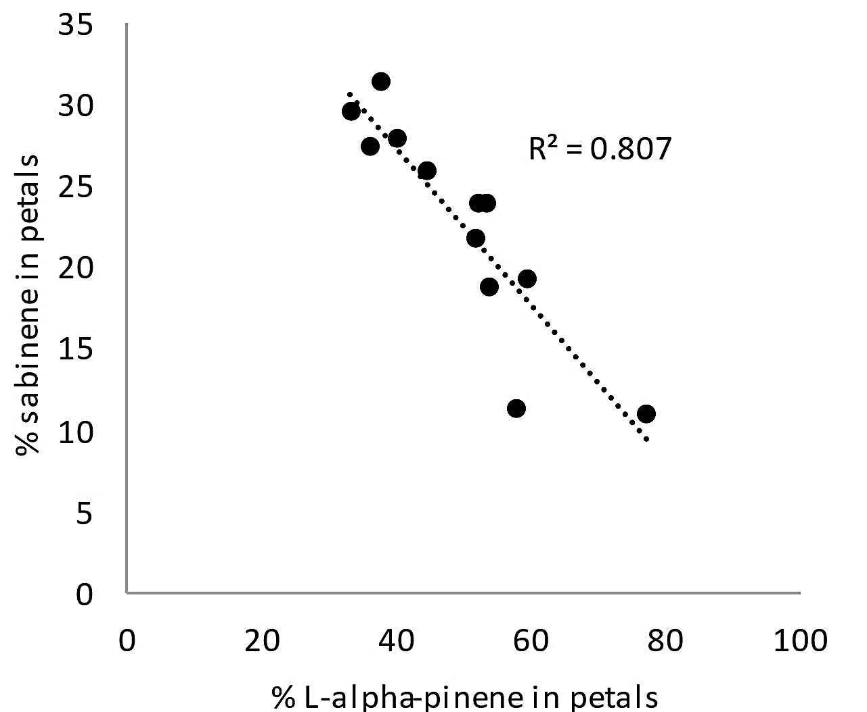 | 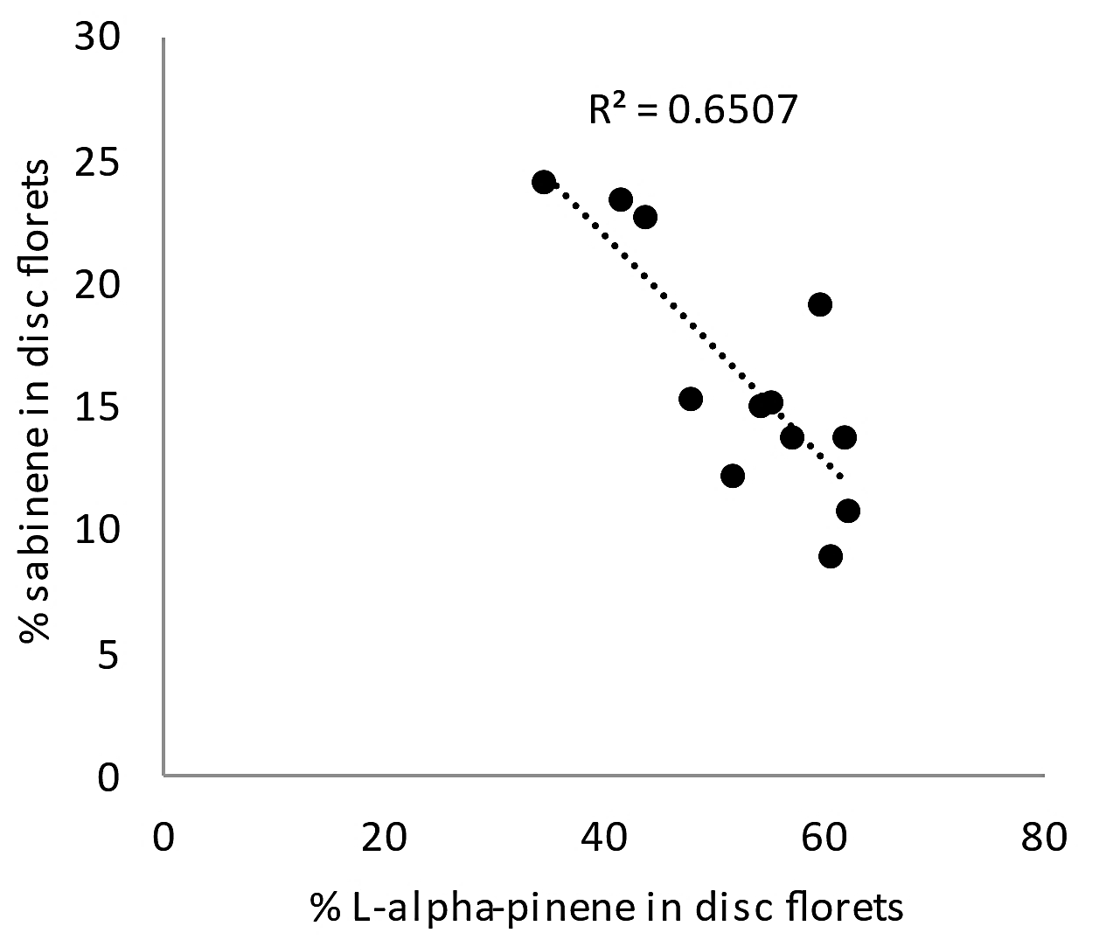

Figure S1. Left: negative correlation among the Core 12 genotypes between L-alpha-pinene and sabinene in petals. Right: negative correlation among the Core 12 genotypes between L-alpha-pinene and sabinene in disc florets.
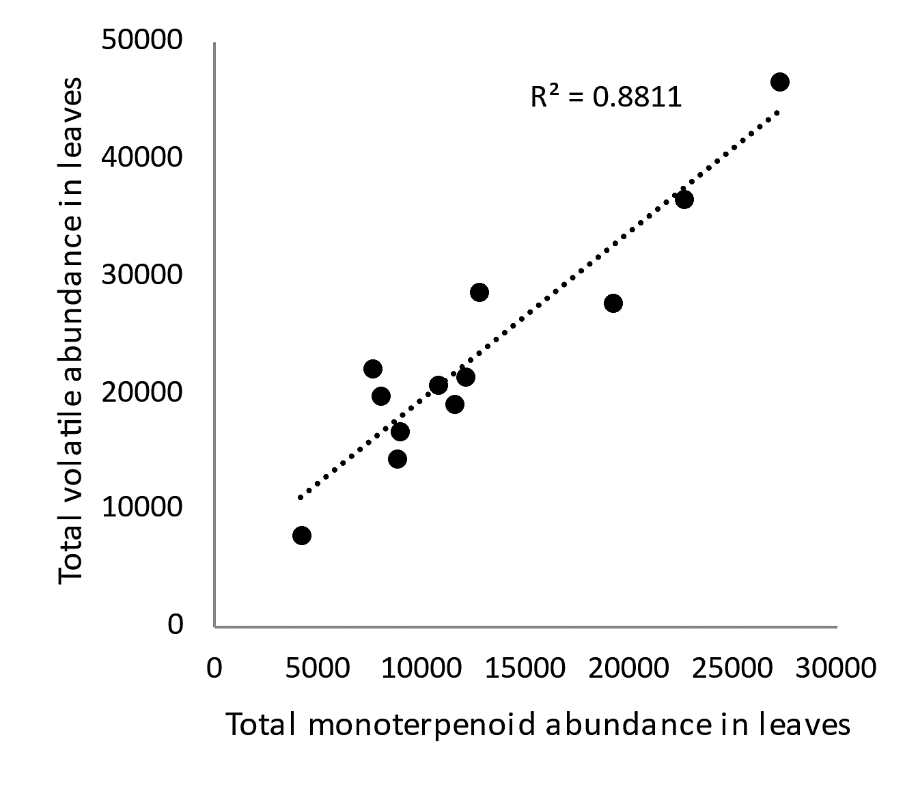 | 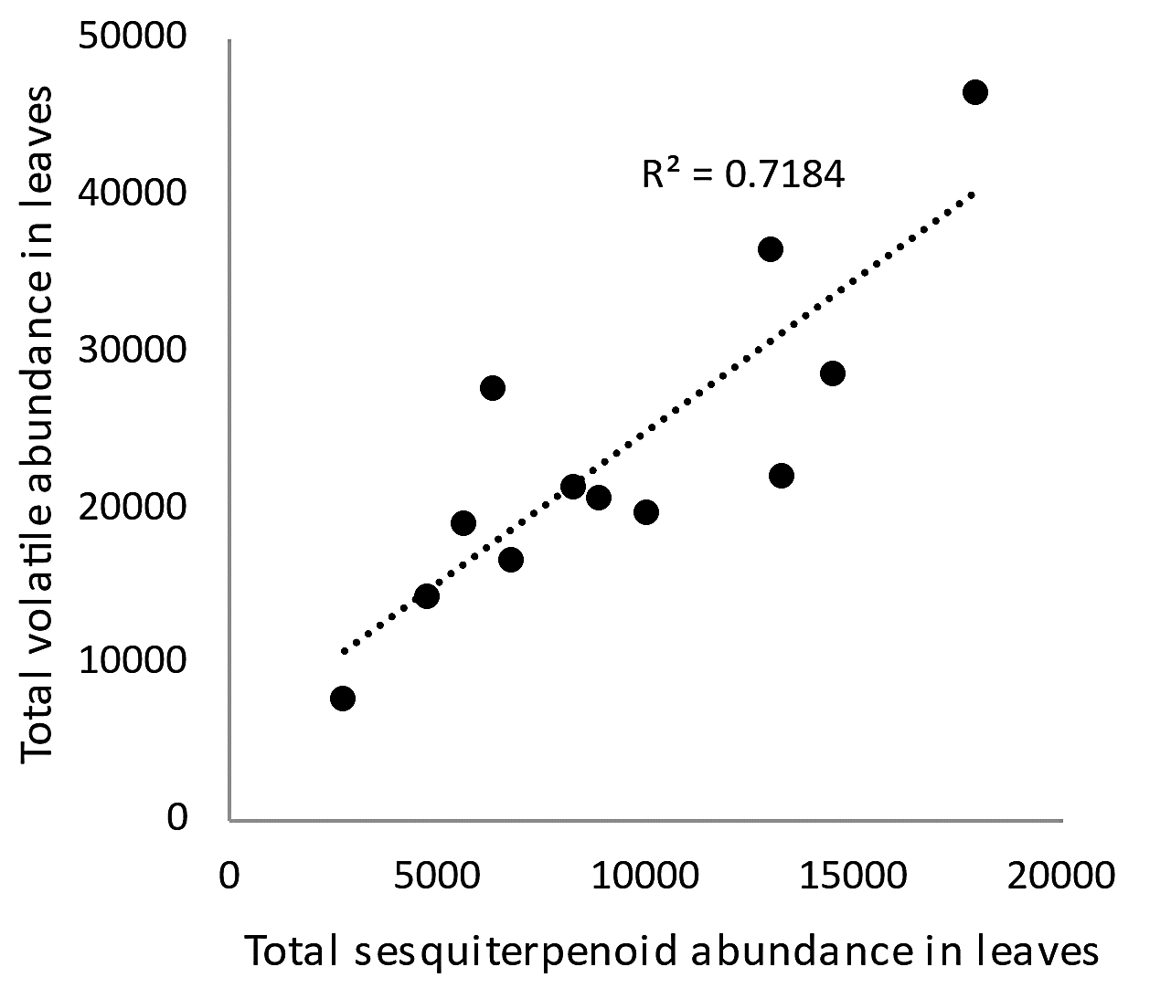
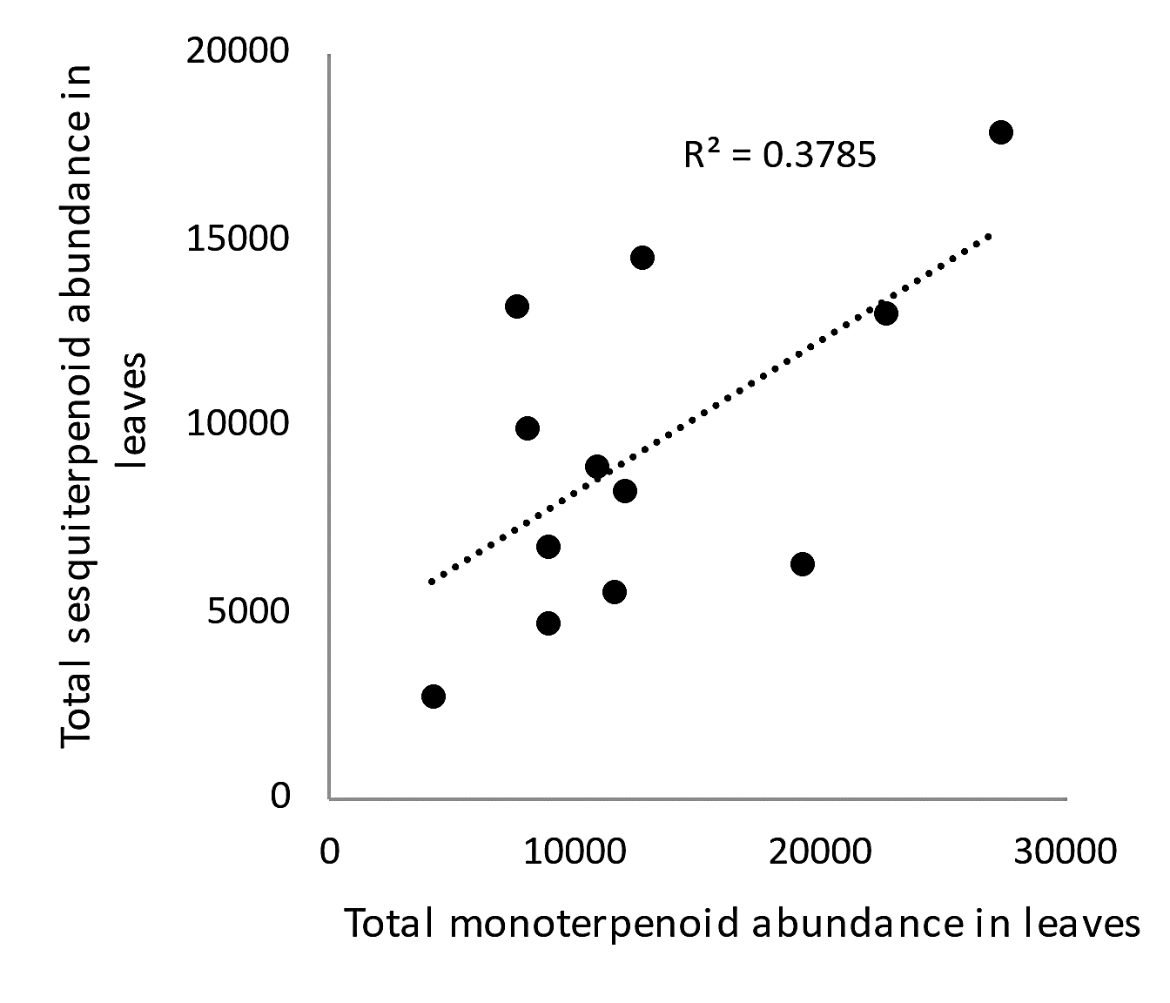

Figure S2. Left: positive correlation among the Core 12 genotypes between total monoterpenoid abundance and total volatile abundance in leaves. Middle: positive correlation among the Core 12 genotypes between total sesquiterpenoid abundance and total volatile abundance in leaves. Right: positive correlation among the Core 12 genotypes between the total monoterpenoid abundance and total sesquiterpenoid abundance in leaves.

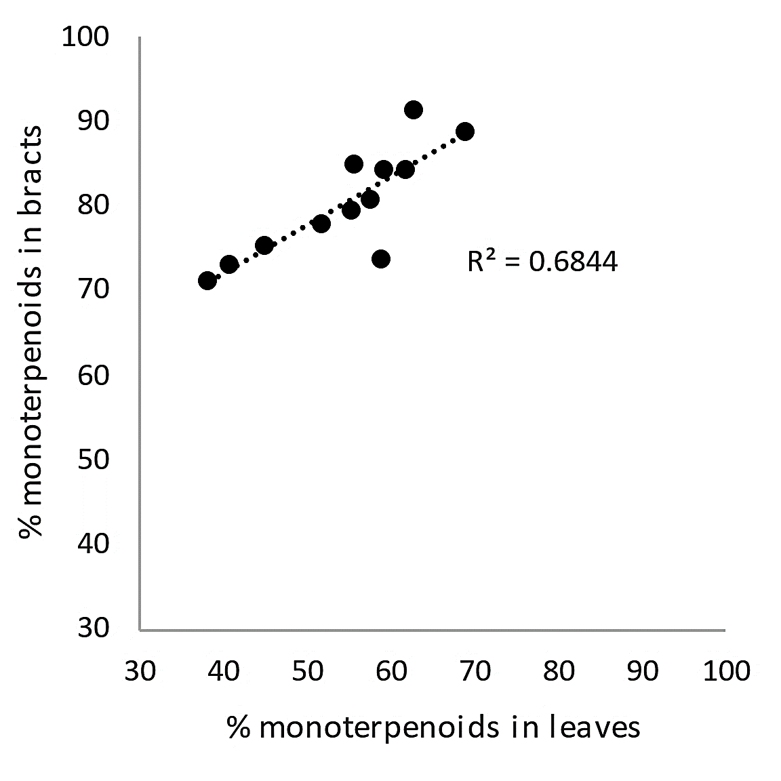 | 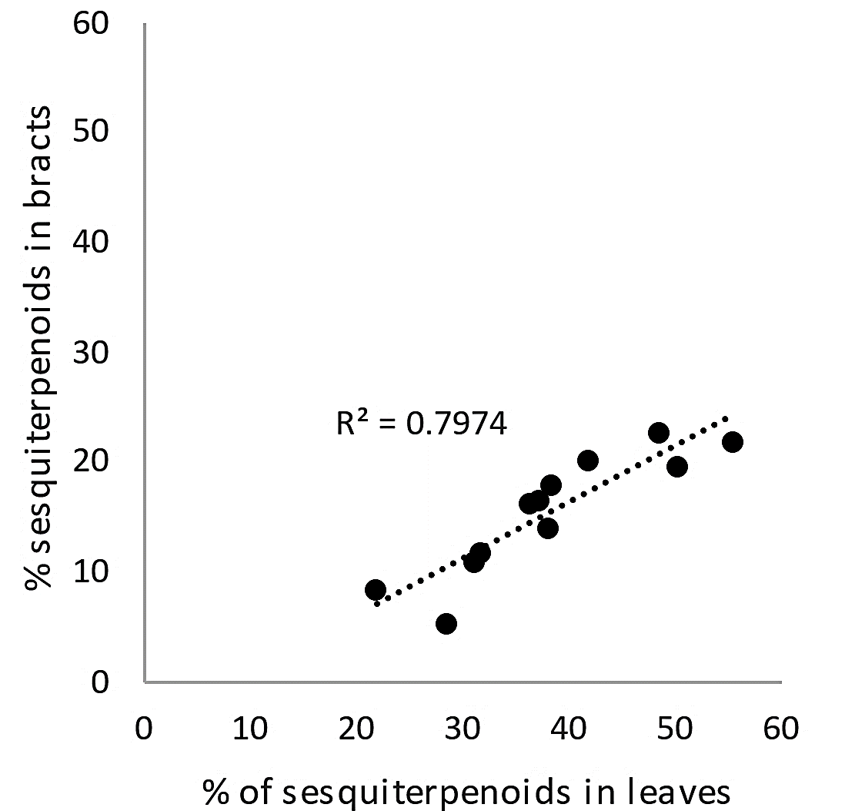

Figure S3. Left: positive correlation among the Core 12 genotypes between the proportion of monoterpenoids in bracts and the proportion of monoterpenoids in leaves. Right: positive correlation among the Core 12 genotypes between the proportion of sesquiterpenoids in bracts and the proportion of sesquiterpenoids in leaves.

